**Kidney Stone Detection in Ultrasound Images**

**Nourhan Amr 2022/05080**

**Dr Alaa Hamdy**

**TA Abdelrahman Atif**

1. **Sample Dataset**

**Link drive for images:** <https://drive.google.com/drive/folders/1Vpj3ka_Efv7DqQyfOiAAqgntfN6kuQlo?usp=sharing>

Below is a sample of the Kidney images that will be used in this project to detect kidney stones:

With stones :

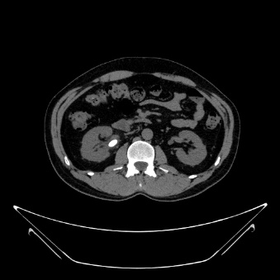

Without stones:

**2. Planned Sequence of Steps**

The following sequence will be followed to complete the project:

1. **Image Acquisition**
2. **Image Restoration**
3. **Image Segmentation**
4. **Representation and Description**
5. **Object Recognition**

**Image Segmentation**

**Image Restoration**

**Image Acquisition**

**Object Recognition**

**Feature Extraction**

**3. Description of Each Step**

**1. Image Acquisition**

* **Description**:  
  Ultrasound images of the kidneys will be collected. The data will consist of grayscale images showing kidneys with possible kidney stones. Also, there will be images without stones to detect that the kidneys are normal.
* **Tools**:

1. 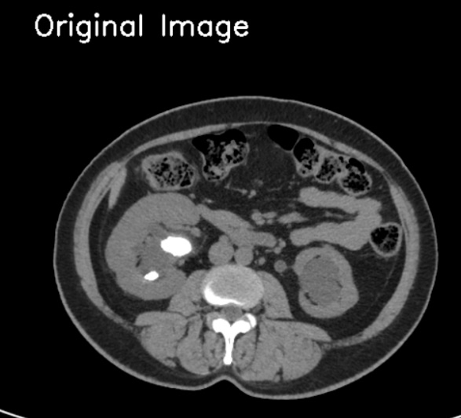Drive.mount: used to access my google drive to access the images.
2. imread:loads image from the drive
3. IMREAD_GRAYSCALE: ensures that the image read in greyscale mode because it’s medical images and it must be in grey scale mode.

**2. Image Restoration**

* **Description**:  
  Restore any degraded images caused by noise or blurring in the ultrasound capture process by using median filter (best type of restoration to reduce noise in medical images).

* 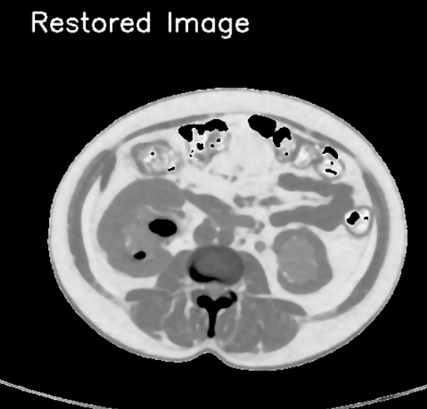**Tools**:

1. Median() using median function which applies median filter to the image to remove any noise.

**3. Image Segmentation**

* 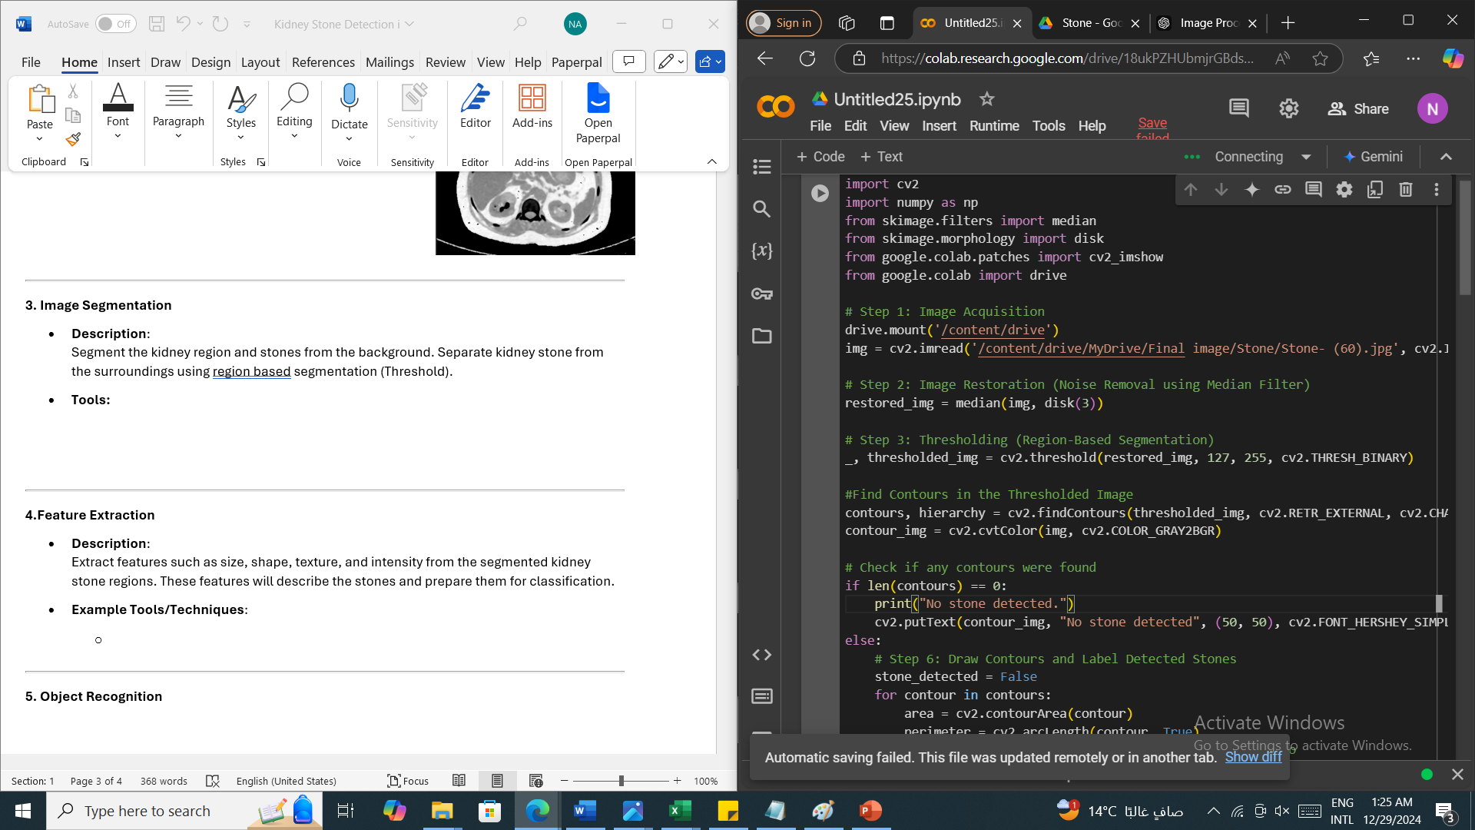**Description**:  
  Segment the kidney region and stones from the background. Separate kidney stone from the surroundings using region based segmentation (Threshold).
* **Tools:**

1. 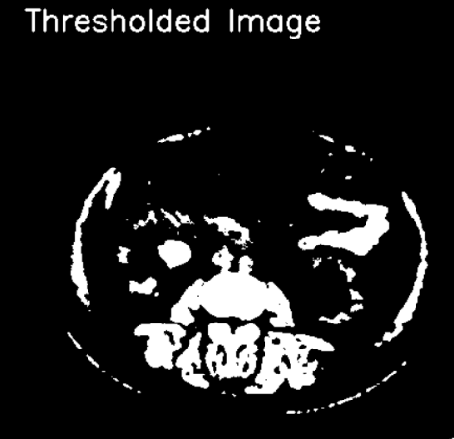This step convert image to binary image where pixels values are either 0 (black) or 255 (white).
2. threshold(): takes restored image as an input with 127 threshold value. All pixel intensities above 127 are set to 255 (white) and all below are set to 0 (black).
3. Thresh_binary: convert image into binary image to make it easier to detect objects.

**4.Feature Extraction (Representation and Description)**

* **Description**:  
  Extract features such as size, shape, texture, and intensity from the segmented kidney stone regions. These features will describe the stones and label them if there is stone using contours(is the outline of any object inside the image).
* **Tools:**

1. findContours: is used to detect contours inside the binary threshold image, it takes parameters

* threshold_img which is the binary image.
* cv2.RETR_EXTERNAL which returns only the outermost contours and ignore internal contours because I only need external boundaries don’t need to go to the details of the stones or objects inside stone.
* Cv2.CHAIN_APPROX_SIMPLE used for reducing memory usage.
* Function return the contours and the hierarchy (information about the relationship between the contours not needed).

1. Cv2.cvtColor(): is used to convert image to BGR colored image to be able to label the contours.

* Check if any contours were found , if there is no stones then a text will be written above picture no stone detected.

* Here we loop over each contour inside the detected contours and calculates area using cv2.contourArea() and calculates perimeter of each contour using cv2.arcLength(), also we check whether the perimeter is 0 or not to avoid division by zero.

**5. Object Recognition**

* **Description**:  
  Identify whether the segmented regions are kidney stone or not.
* **Tools**:

* In this step we filter too small contours (area<100).
* fitEllipse() helps in analyzing the properties of the contour by fitting an ellipse (shape around the contour), this function returns the center coordinates , the minor axis(ma) , major axis (MA) and the rotation angle.
* Using eccentricity to be more accurate in detecting stone (ma/MA)

* Filter out contours based on eccentricity and perimeter. Eccentricity must have value between 0(perfect circle) and 2.5(oval or nearly circular shape). Perimeter between 100 and 150 to exclude very large contours and very small contours.
* drawContours() function used to draw contours around stone detected.
* Calculate center of detetcted stone to label the word stone beside the detected part by using moments() where we calculate x and y coordinates then putText stone on the image of the calculated axis.
* Last step is to display the images

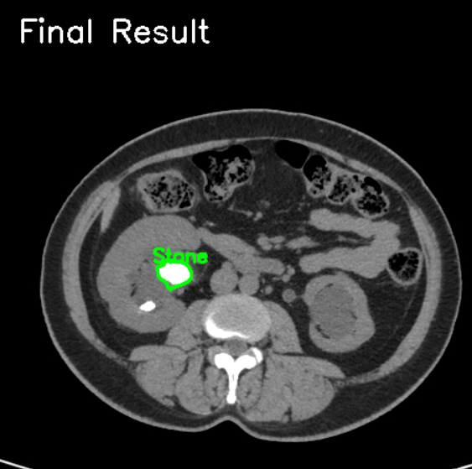

**Conclusion**

The kidney stone detection project utilizes digital image processing techniques to identify stones in CT scan images. By following a structured sequence of steps, including image acquisition, enhancement, segmentation, and object recognition, the project aims to deliver an accurate and efficient detection pipeline.